**LEGO (INSTRUCTION MANUAL)**

* Lego is a line of plastic construction toys that are manufactured by The Lego Group, a privately held company based in Billund, Denmark. As of 2021, Lego was the largest toy company in the world. The company's flagship product, Lego, consists of variously colored interlocking plastic bricks accompanying an array of gears, figurines called minifigures and various other parts. Lego pieces can be assembled and connected in many ways to construct objects, including vehicles, buildings, and working robots. Anything constructed can be taken apart again, and the pieces reused to make new things.
* The Lego Group began manufacturing the interlocking toy bricks in 1949. Movies, games, competitions and eight LEGOLAND amusement parks have been developed under the brand. As of July 2015, 600 billion Lego parts had been produced.
* Visit: <https://www.lego.com/en-us> for further Information.
* NOTE: WE ONLY HAVE RENTAL LEGO SETS AVAILABLE FOR FURTHER OR LONG TERM PURCHASES VISIT THE GIVEN LINK.



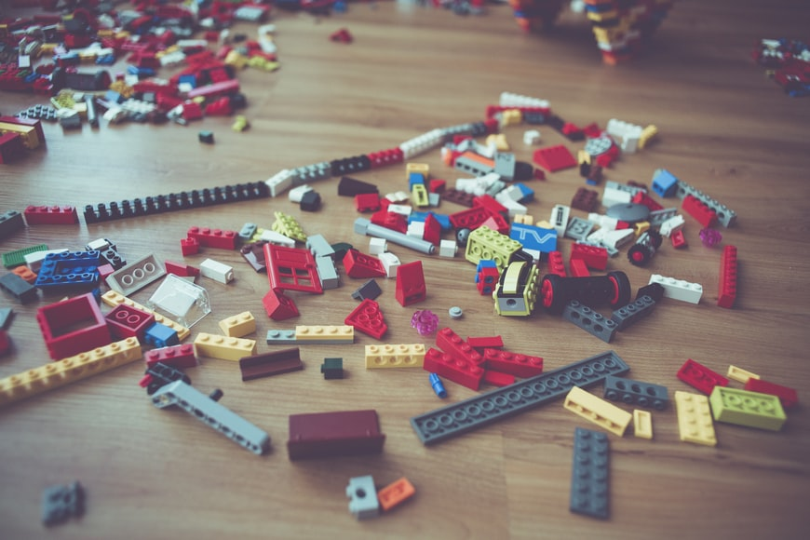

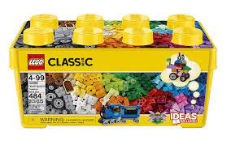 LEGO CLASSIC- BUILD IT YOUR WAY!

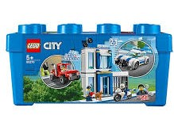

LEGO CITY- IMAGINATION IS

JUST THE BEGINNING!

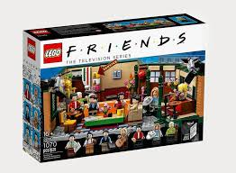

LEGO friends- we love m MONDLER! Who is your

Favorite?!